# **DAY 5 - TESTING, ERROR HANDLING, AND BACKEND INTEGRATION REFINEMENT**

**STEP # 1: FUNCTIONAL TESTING**

I have performed functional testing on the following features of the application:

1. **Night Mode Implementation**
   * Verified that the night mode toggle works correctly.
   * Ensured that UI elements adjust properly to dark mode.
   * Persistent across page navigation.
2. **FAQs Section**
   * Checked that FAQs are displayed properly.
   * Verified expand/collapse functionality.
   * Ensured responsiveness on different screen sizes.
3. **Add to Cart & Dynamic Route (Product Detail Page)**
   * Ensured products can be added to the cart correctly.
   * Verified that the dynamic route for product details works as expected.
   * Checked that product details (name, price, description, image) load correctly.
4. **Checkout Page**
   * Confirmed that selected cart items appear correctly.
   * Tested form validation for required fields.
   * Ensured proper redirection after order confirmation.

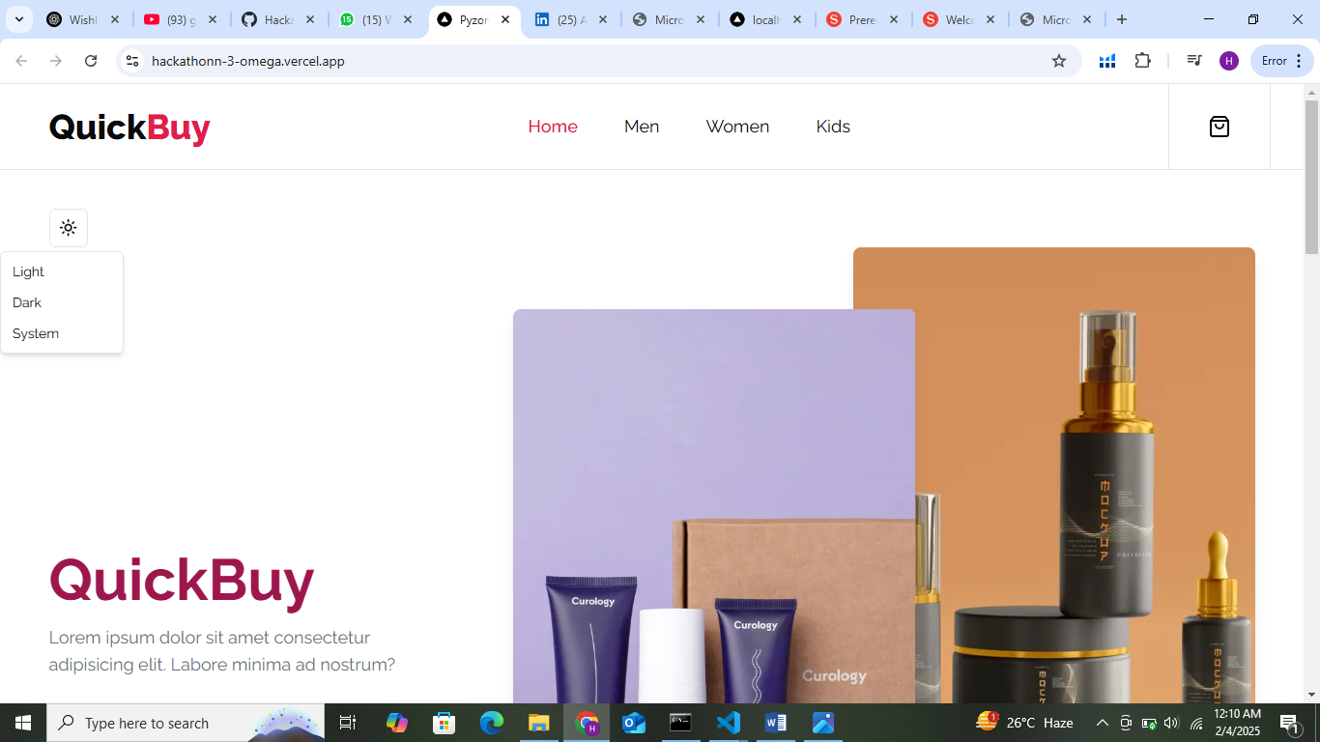

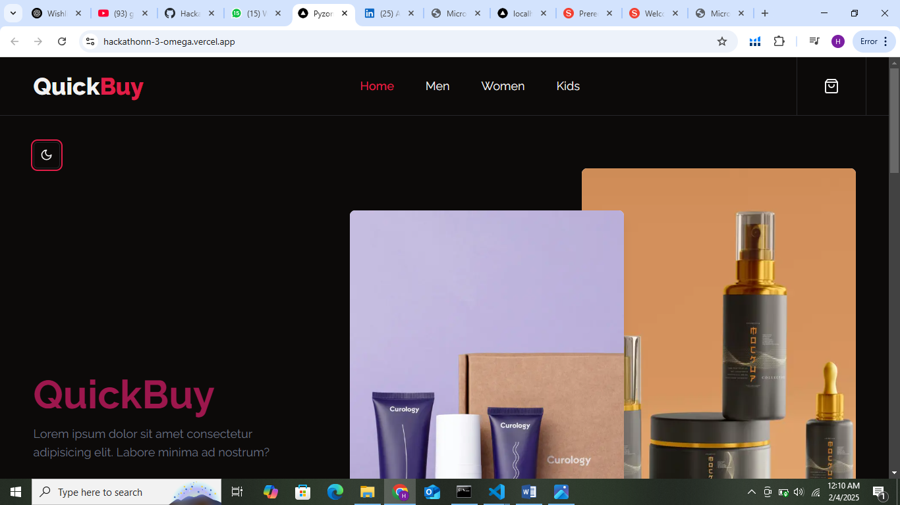

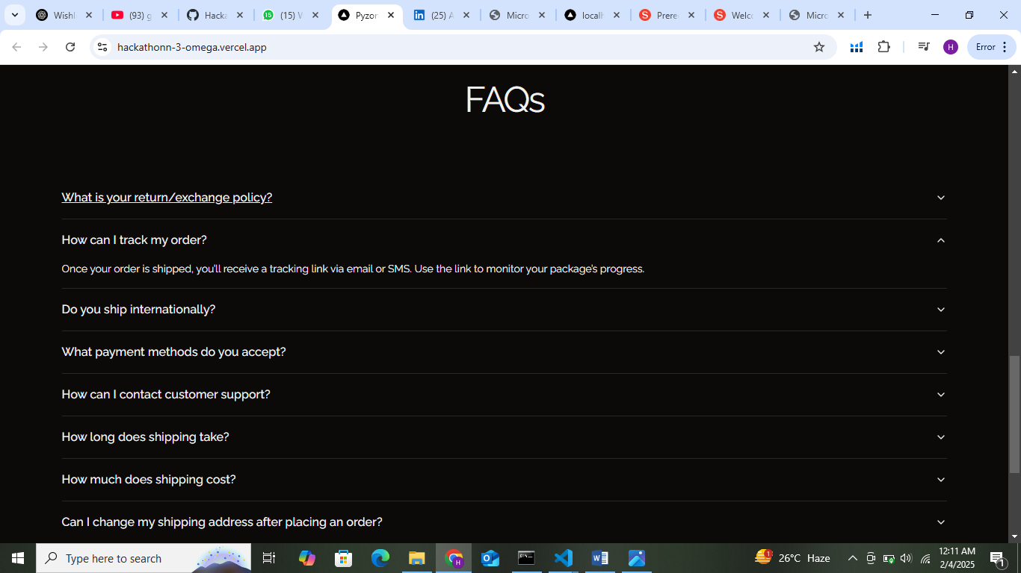

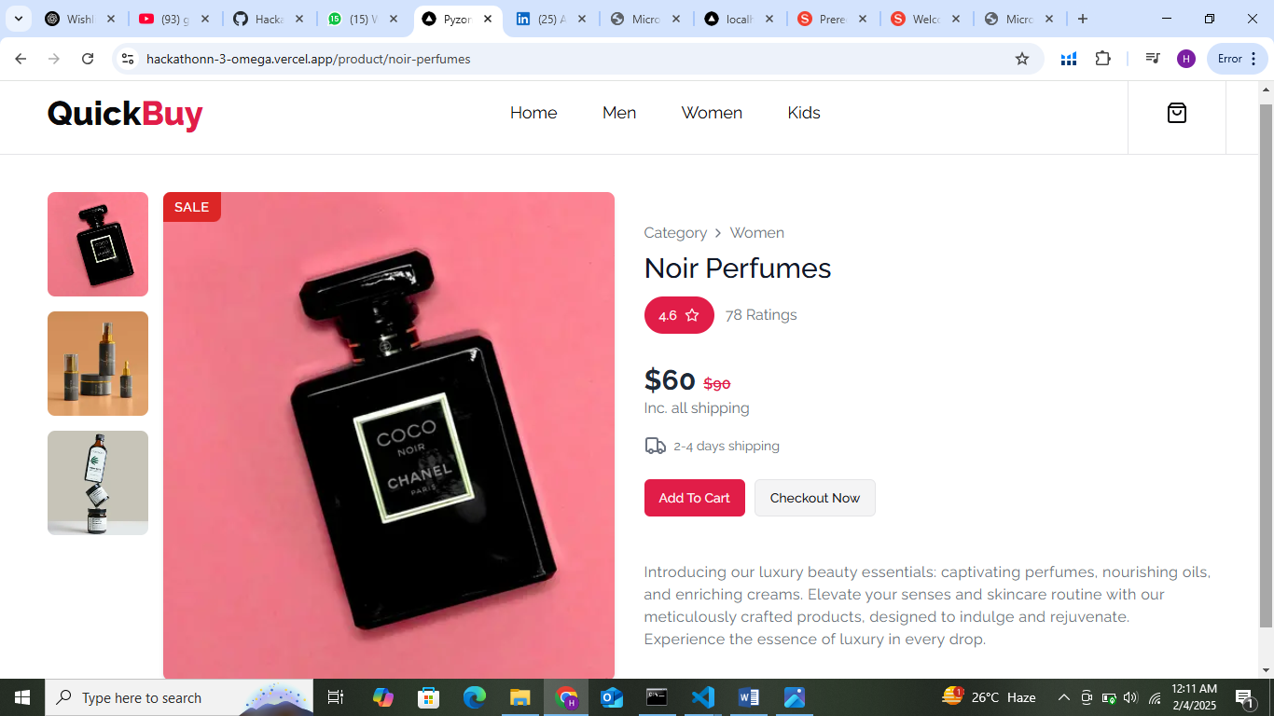

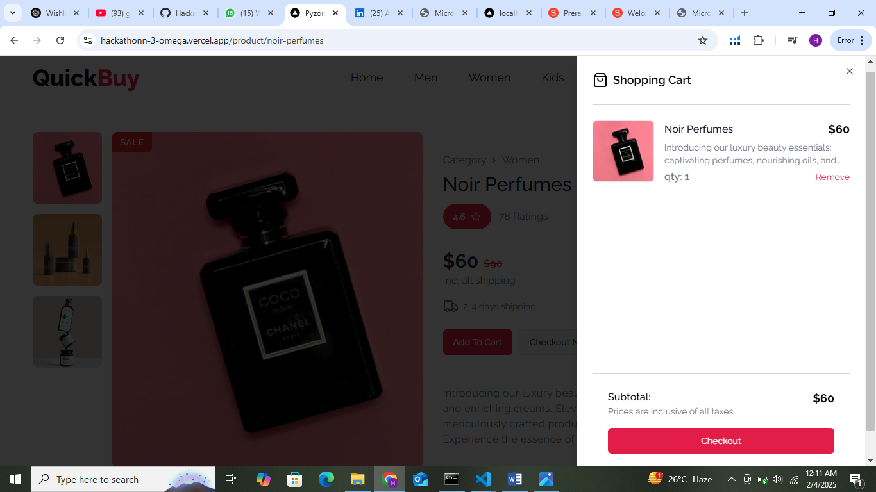

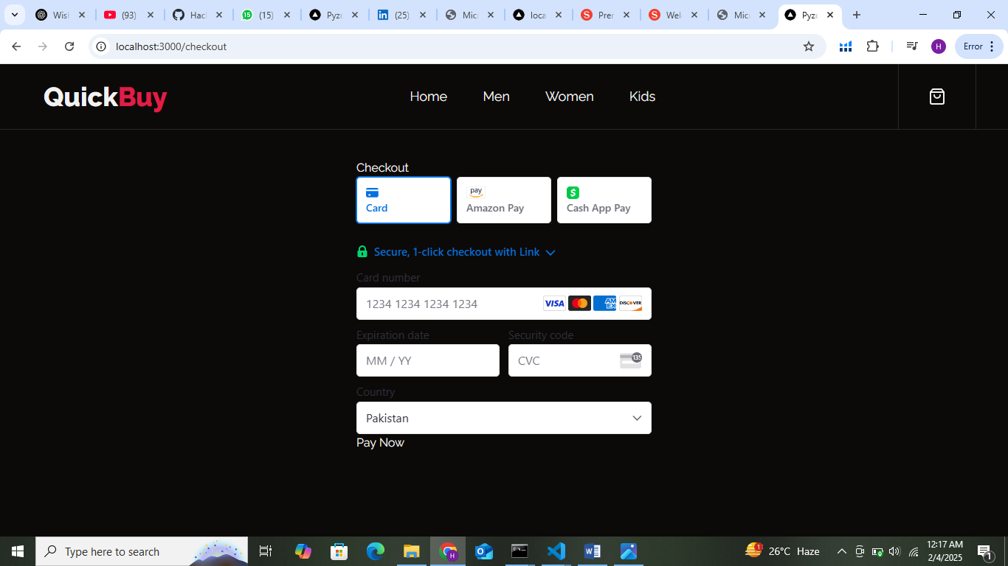

**STEP # 2: Error Handling**

**Error Handling**: There is no error handling in the APIs, and it is working properly without any issues.

**Step 3: Performance Optimization**

|  |  |  |  |  |  |  |  |  |
| --- | --- | --- | --- | --- | --- | --- | --- | --- |
|  | **Test Case ID** | **Test Case Description** | **Test Steps** | **Expected Result** | **Actual Result** | **Status** | **Severity level** | **Remarks** |
| 2 | TC001 | Validate product listing page | Open product page > Verify products | Products displayed correctly | Products displayed correctly | Passed | High | -No issues found |
| 3 | TC002 | Test API error handling | Disconnect API > Refresh page | Show fallback UI with error message | Error message shown | Passed | Medium | Handeled gracefully |
| 4 | TC003 | Check cart functionality | Add product to cart > Verify cart contents | Cart updates with added product | Cart updates as expected | Passed | High | Test successful |
| 5 | TC004 | Ensure responsiveness on mobile | Resize browser window > Check layout | Layout adjusts properly to screen size | Responsive layout working as intended | Passed | Medium | Worked as expected |

**LIGHTHOUSE REPORT:**

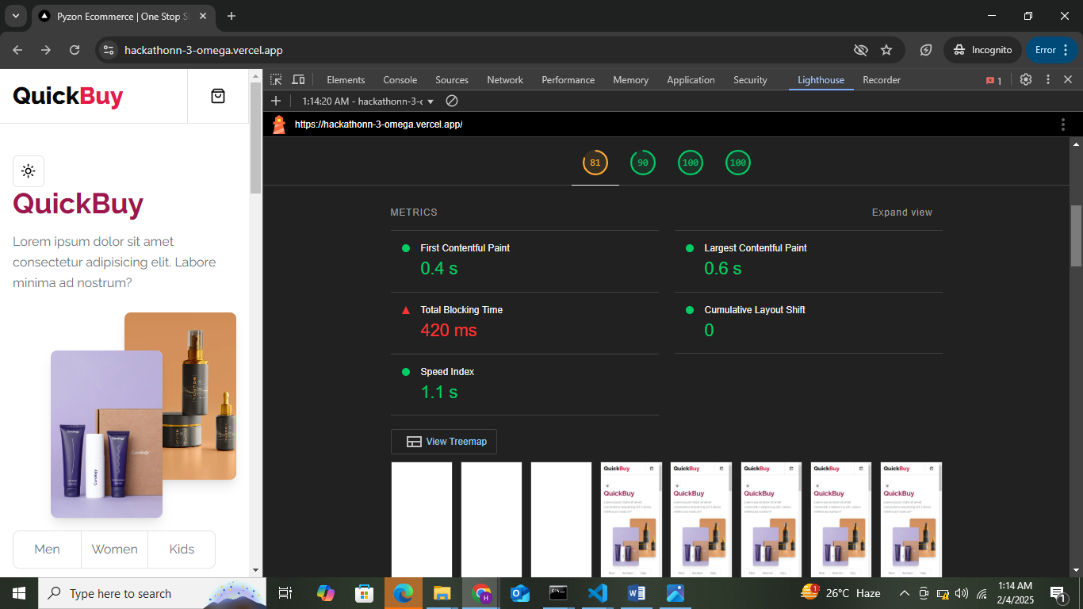

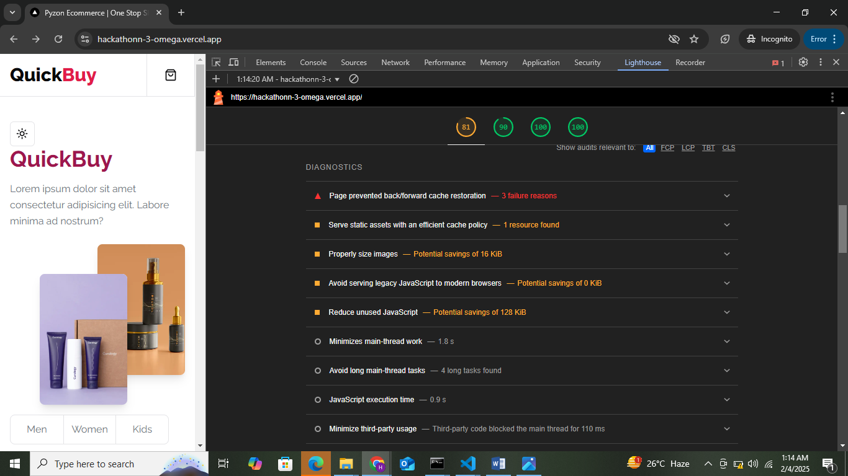

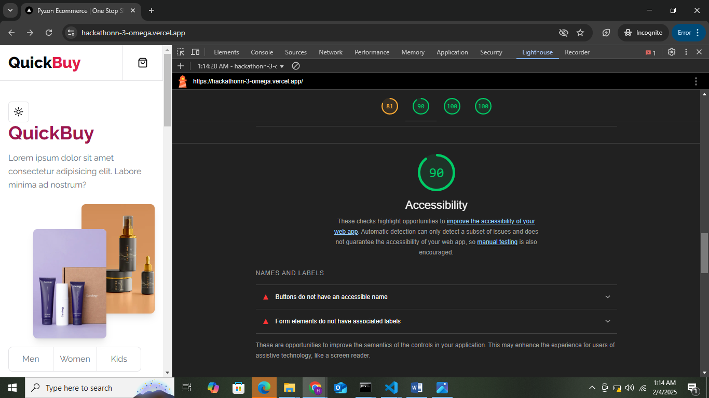

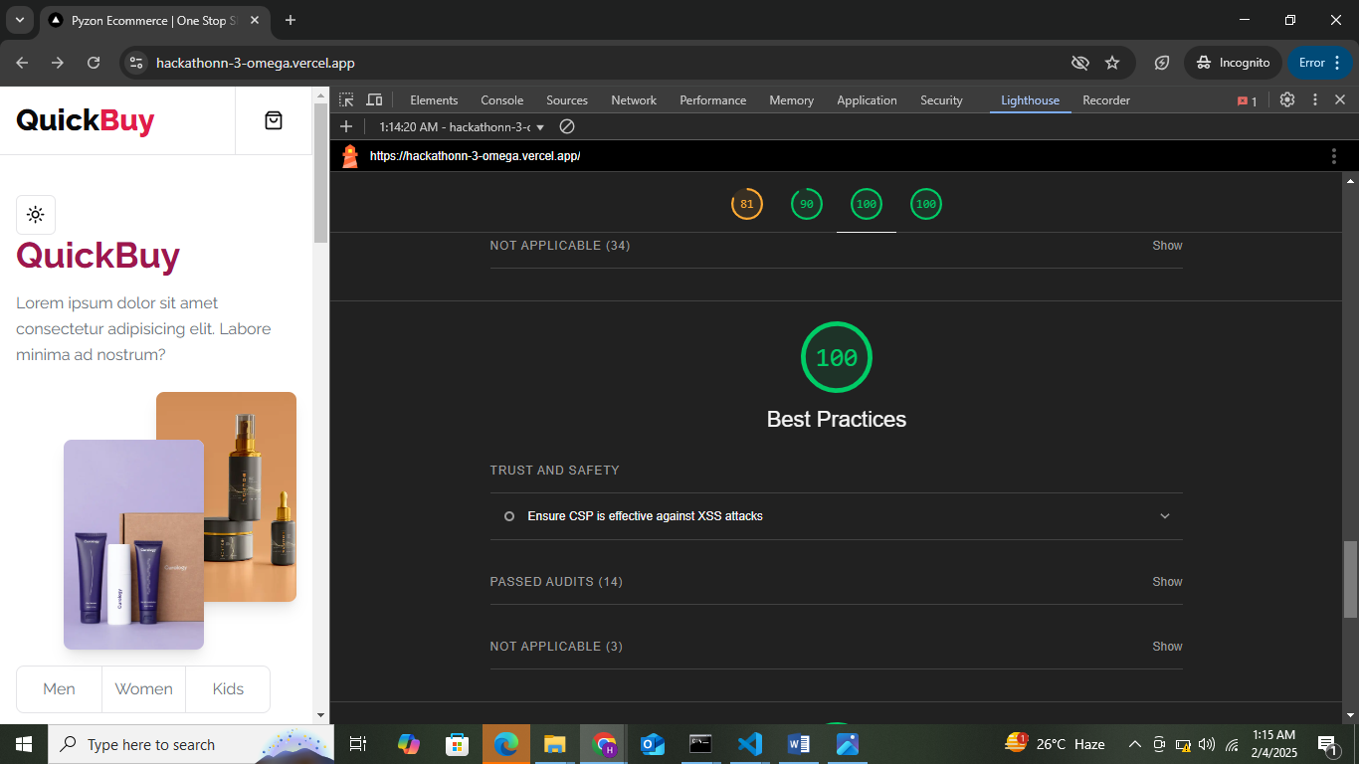

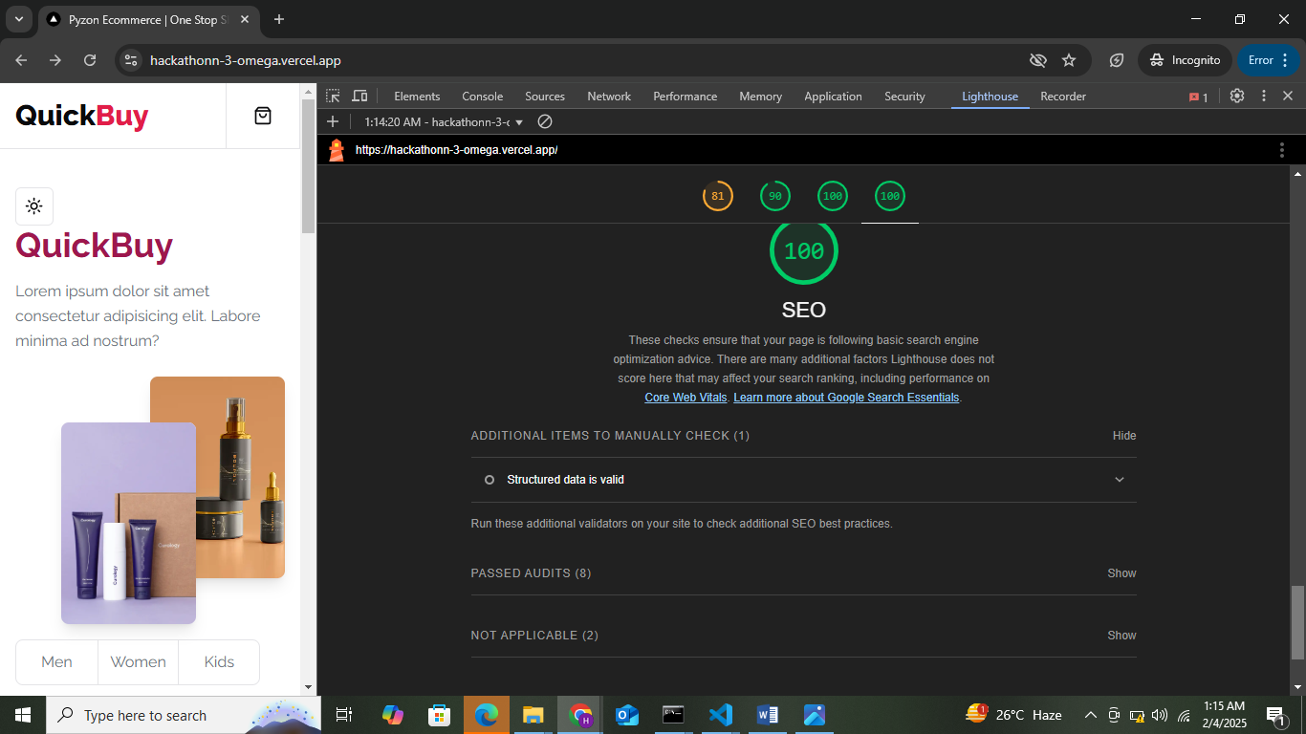

**DEVELOPER RESOURCES:**

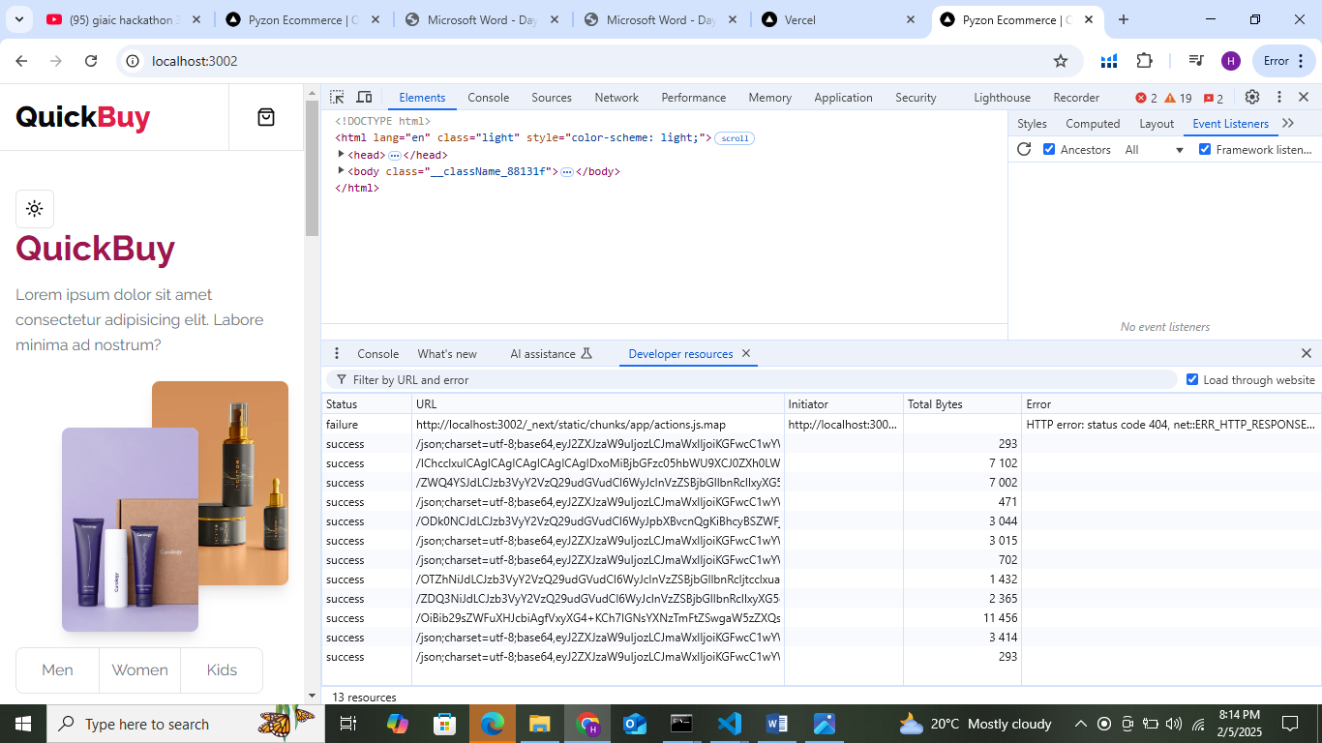

**PERFORMANCE MONITOR:**

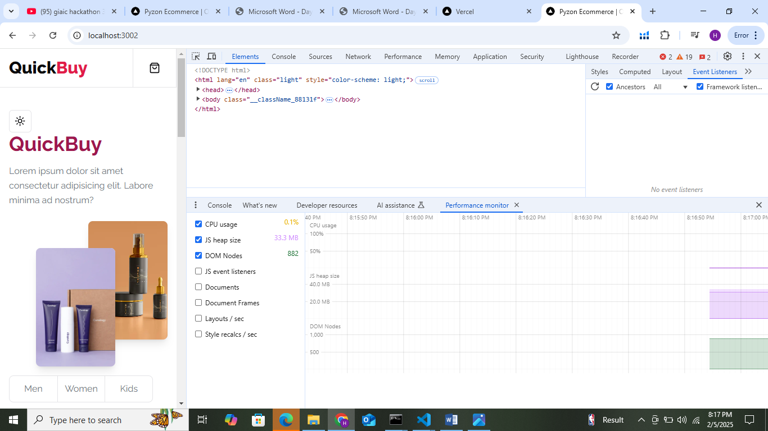

**SECURITY:**

